**The Application**

The personality model we have built is flexible and can be applied to a range of text data. For demonstrative purposes, we took the results of the yelp comment personalities types and created an interactable dashboard that simulates a business-like scenario. The comment ratings provide explicit feedback which is indicative of user incentive and suggests asymmetry between personalities.

The application is intended for broad analysis, allowing for two businesses in the processed dataset to be compared against each other. Notably, it will display relevant metrics, such as price ranges and location. As well as features, such as if smoking is permitted, or the suitability for young children. These of which, are provided directly from the yelp dataset.

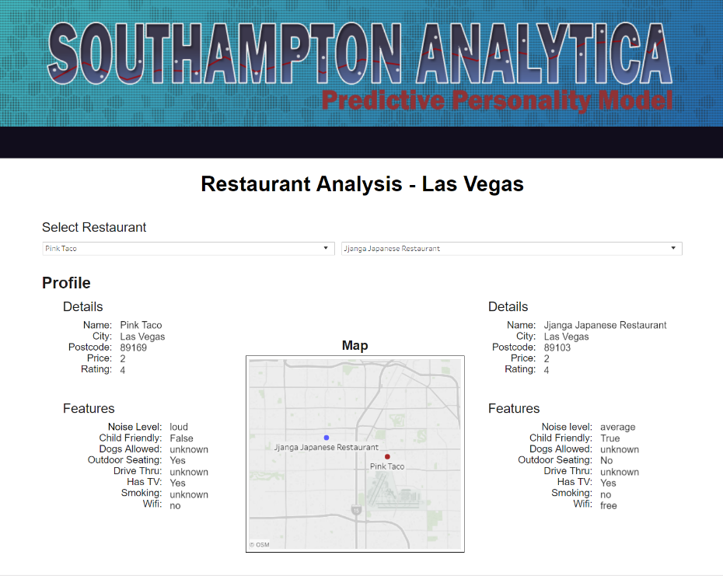

**Figure 3):** The main dashboard view, where businesses can be selected and mapped based on locational data.

Additionally, a word cloud is generated from the 50 most frequent terms (after eliminating stop words). Which is helpful, as an overview of the language being used and provides insight into the model’s predictive functionality. This is accompanied by a graph showing the distribution of user ratings for each of the applicable personality types (ESTJ - INFP). As well as a trends chart which reflects the average user ratings overtime.

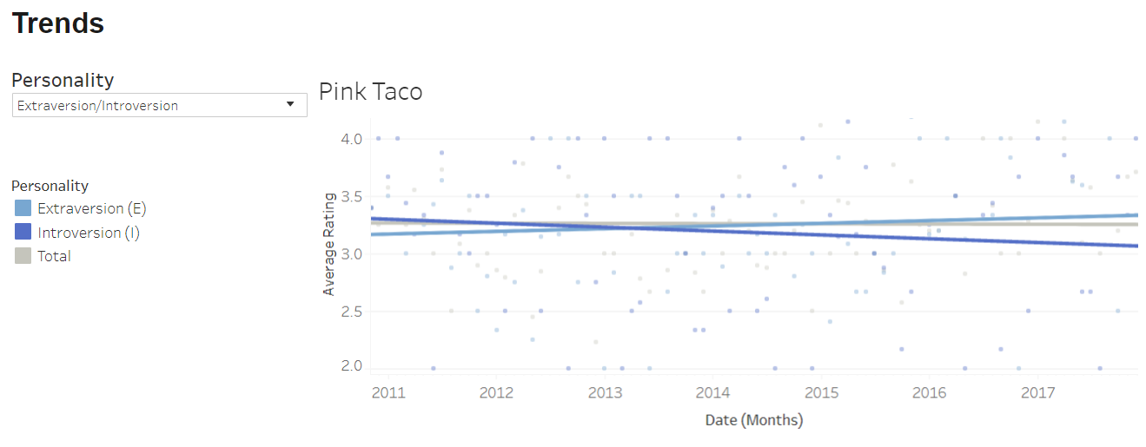

**Figure 4):** The trends chart – note that the personality average rating switches in 2013, despite the total average rating staying relatively static. This would hint that the business has appealed more to extraverted customers in recent years.

The application, along with the model, could provide helpful information that would influence business decisions. It is also feasibly expandable to include more locations and business types in the future.